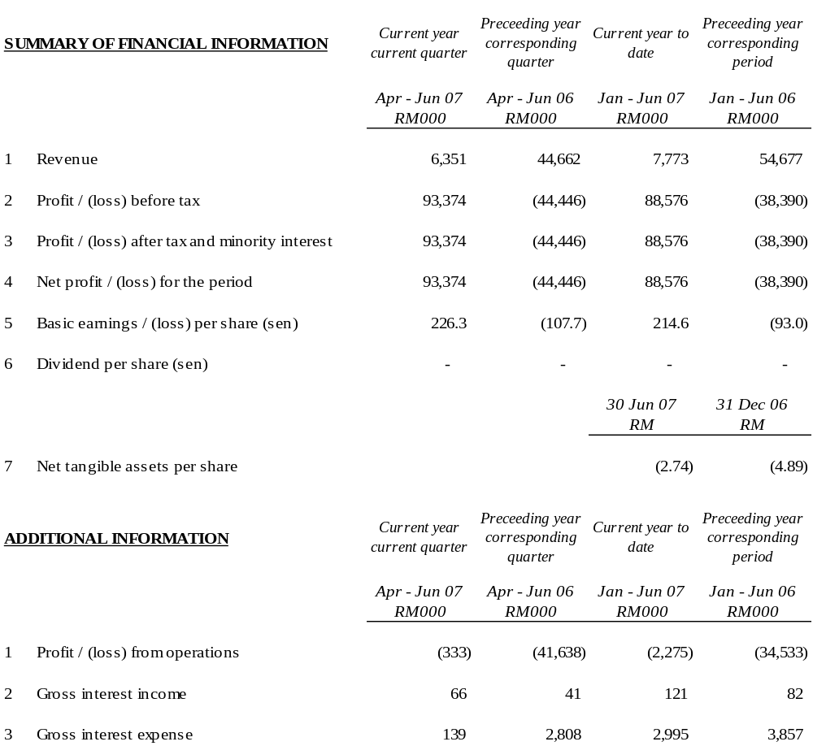

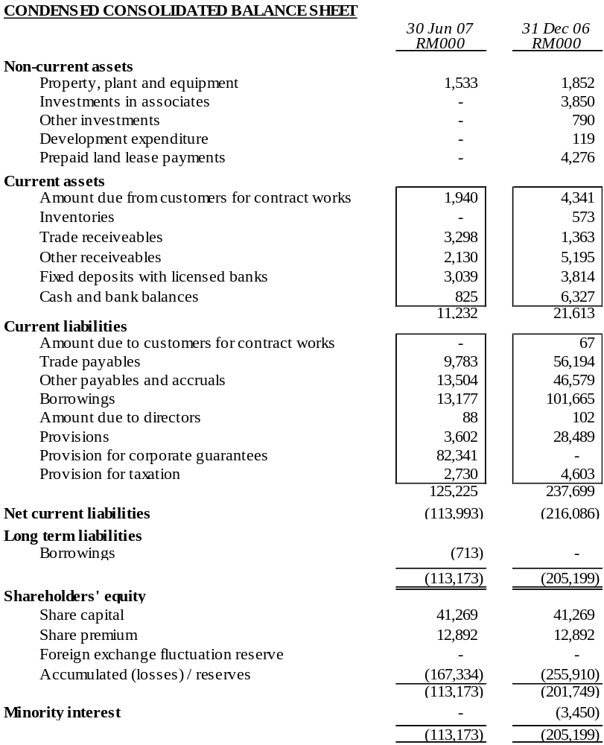

The condensed consolidated balance sheet should be read in conjunction with the Annual Financial Report for the year ended 31 December 2006.

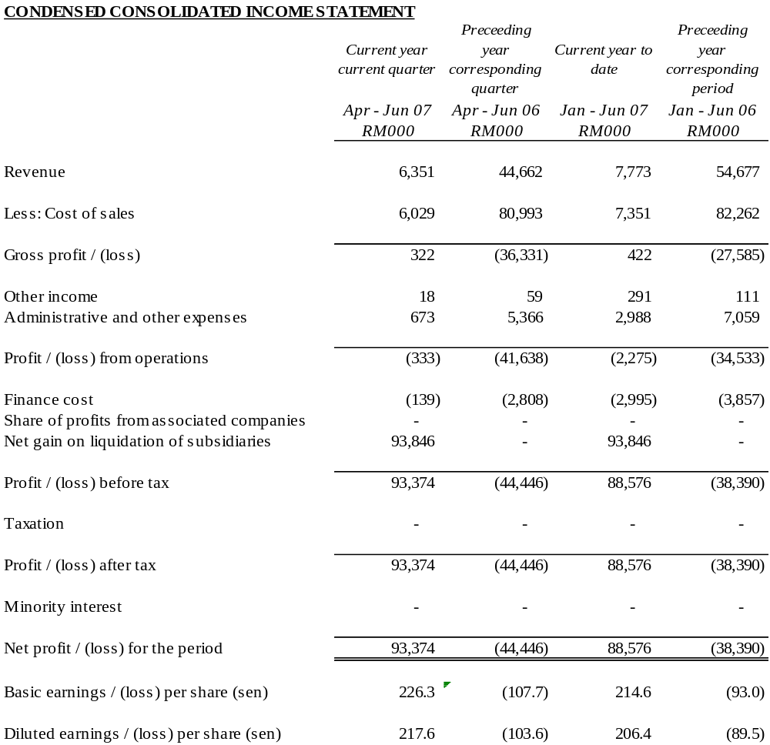

The condensed consolidated income statement should be read in conjunction with the Annual Financial Report for the year ended 31 December 2006.

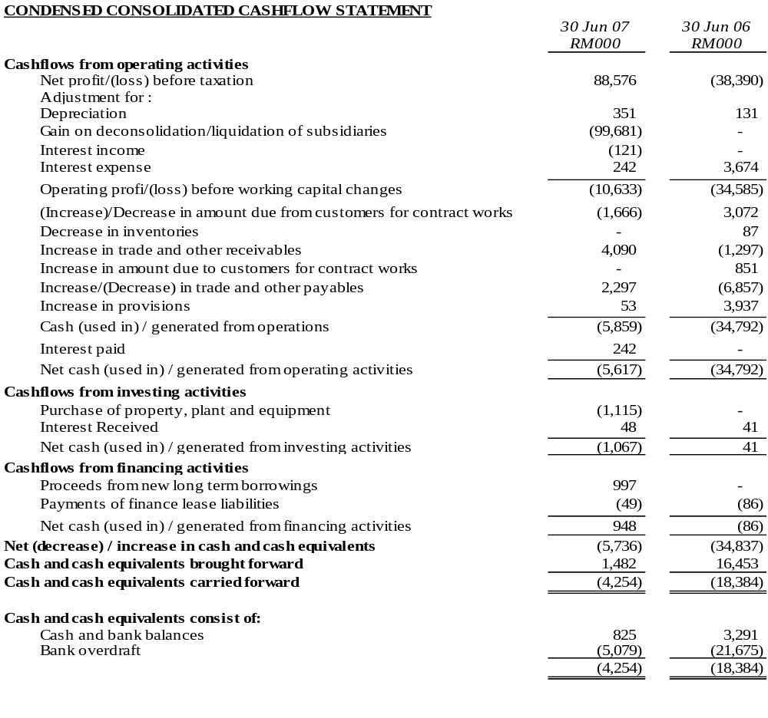

The condensed consolidated cashflow statement should be read in conjunction with the Annual Financial Report for the year ended 31 December 2006.

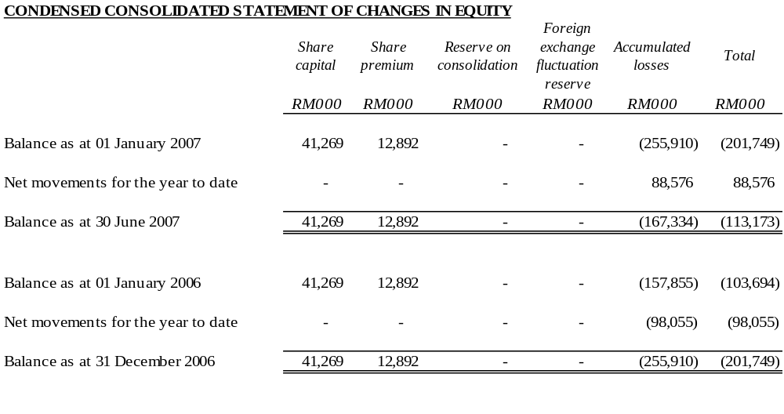

The condensed consolidated statement of changes in equity should be read in conjunction with the Annual Financial Report for the year ended 31 December 2006.

EXPLANATORY NOTES

1. BASIS OF PREPARATION
The interim financial statements are unaudited and have been prepared in accordance with the requirements of Financial Reporting Standard (FRS) 134, Interim Financial Reporting issued by the Malaysian Accounting Standards Board (MASB) and paragraph 9.22 and Appendix 9B of the Listing Requirements of Bursa Malaysia Securities Berhad.
The interim financial statements should be read in conjunction with the audited financial statements of the Group for the year ended 31 December 2006.
2. CHANGE IN ACCOUNTING POLICIES
The accounting policies and methods of computation adopted by the Group in these quarterly financial statements are consistent with those adopted in the most recent annual audited financial statements for the year ended 31 December 2006, except that the Group has adopted the new/revised standards mandatory for annual periods beginning on or after 1 January 2007, as follows:

FRS 117 | Leases
FRS 119₂₀₀₄ (Revised) | Employee Benefits – Actuarial Gains and Losses, Group Plans and Disclosures
FRS 124 | Related Party Disclosures

The adoption of the above FRSs does not have any significant financial impact on the Group.
3. AUDIT REPORT OF PRECEDING FINANCIAL STATEMENT
The annual financial statements of the Group for the year ended 31 December 2006 were reported with qualification in respect to the ability of the Group and the Company to be able to continue as going concerns.
The Company together with a team of professionals had on 23 January submitted its Proposed Corporate Restructuring Exercise (“PCRE”) to the Securities Commission (“SC”) which was subsequently approved by the SC on 30 April 2007 (the details to which are further explained in Note 10 below).
The Company is presently taking the necessary steps to implement the aforesaid PCRE.
4. EXCEPTIONAL ITEMS

The items affecting assets, liabilities, equity, net income or cashflows that are unusual because of their nature, size or incidence have been included in the interim financial statements. Kindly refer to note 18.
5. CHANGES IN ESTIMATES
There were no changes in estimates of amounts that give a material effect for the current quarter.
6. TAXATION
Taxation for the current period is as follows:
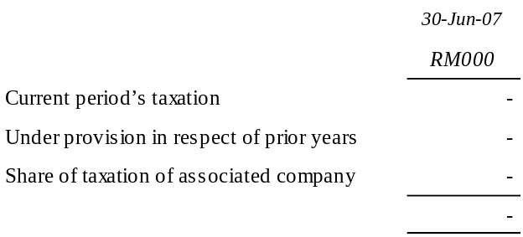
No taxation has been provided in the current year to date since the companies are in a loss position.
7. SALE OF UNQUOTED INVESTMENTS / PROPERTIES

There has been no disposal of any unquoted securities or properties during the current quarter, apart from the financial effects of the deconsolidation of LPC as explained in notes 8 and 9 below.
8. PURCHASE OR DISPOSAL OF QUOTED SECURITIES

There has been no purchase or disposal of any quoted securities during the current quarter, apart from the financial effects of the deconsolidation of LPC as explained in notes 8 and 9 below.
9. CHANGES IN GROUP COMPOSITION
Lankhorst Pancabumi Contractors Sdn Bhd (“LPC”) has been liquidated on 15 May 2007 in line with the PCRE approved by the SC the details to which are further explained in Note 10 below. As a consequence, LPC has been deconsolidated from the Ark Group as at that date and its financial results and balance sheet are excluded from the current quarters Group financial results and balance sheet.
10. CORPORATE PROPOSALS
The Company had on 23 January 2007 submitted to the SC its PCRE entailing the following:-

Proposed Capital Reduction;
Proposed Acquisitions;
Proposed Debt Restructuring;
Proposed Liquidation;
Proposed Rights Issue with Warrants; and
Proposed Placement with Warrants
The SC had on 30 April 2007 approved the aforementioned PCRE. In this regard, the Company had commenced the implementation of the aforesaid PCRE via liquidation of its subsidiaries. In this regard LPC and Cardon Sdn Bhd (“Cardon”) has been liquidated effective 15 May 2007 and 19 July 2007 respectively, in line with the PCRE.
The Company, Ark M&E Sdn Bhd (fka Lankhorst M&E Sdn Bhd), Ark Development Sdn Bhd (fka Rampai Budi Jaya Sdn Bhd) and Ark Hartanah Sdn Bhd (fka Lankhorst Hartanah Sdn Bhd) had on 21 May 2007 obtained a further extension of the Restraining Order pursuant to S176 (CA 1965) from the High Court of Malaya, Kuala Lumpur by an additional 120 days i.e., to expire on 17 September 2007.
11. ISSUANCE OF EQUITY SECURITIES AND REPAYMENT OF DEBT SECURITIES, SHARE BUY-BACKS, SHARE CANCELLATIONS, SHARES HELD AS TREASURY SHARES AND RESALE OF TREASURY SHARES
There were no other issues of equity securities and repayment of debt securities, share buy-backs, share cancellations, shares held as treasury shares and resale of treasury shares during the current year and quarter.
12. GROUP BORROWINGS
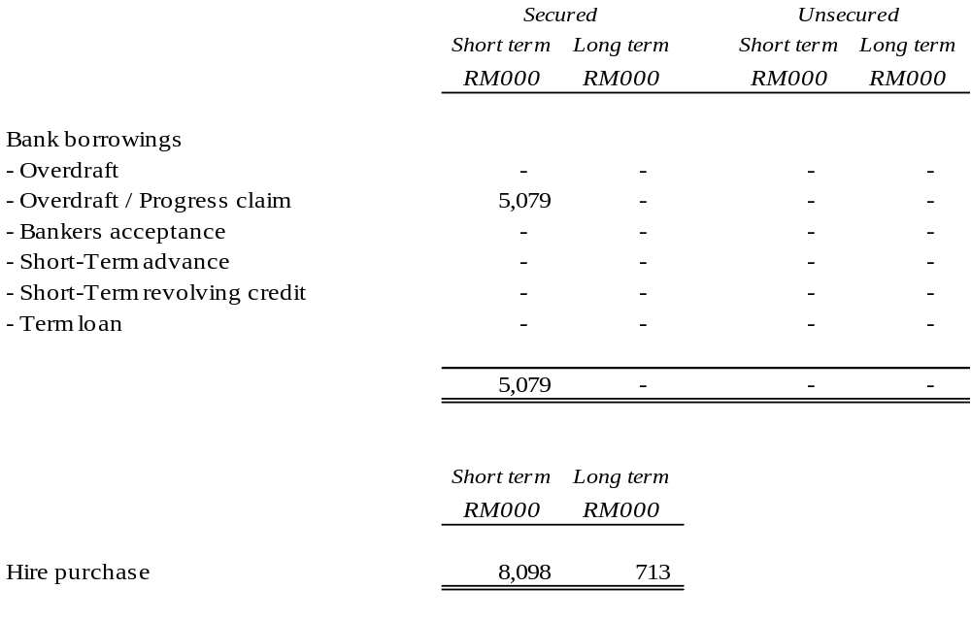
13. CONTINGENT LIABILITIES
The contingent liabilities for the Group is RM1.7 million.
14. OFF-BALANCE SHEET FINANCIAL INSTRUMENTS
As at the latest practicable date from the date of issue of this quarterly report, there are no off-balance sheet financial instruments in issue.
15. CHANGES IN MATERIAL LITIGATION
All litigations pertaining to LPC will be addressed in its liquidation process to be conducted by the appointed liquidator. There are no other changes in material litigation involving the remaining companies of the Ark Group except for the winding-up petition presented by Concrete Engineering Products Berhad against Cardon which was struck-off with no order as to cost on 28 June 2007.
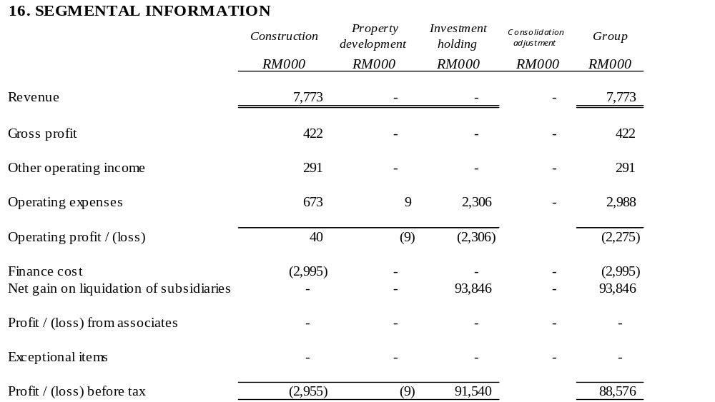

17. REVIEW OF PERFORMANCE

Group revenue decreased by 85.8% for the second quarter 2007 as compared against the corresponding quarter in 2006. The Group recorded a profit before tax of RM93.4 million in the current quarter as compared to a loss of RM44.4 million in the same quarter of the preceding year.
The decrease in revenues for the current quarter as compared to the corresponding quarter last year was due to the completion of all its previous projects. The Group has currently only commenced on its new projects in Thailand, i.e. the construction of low-cost housing for the National Housing Authority of Thailand (Ban Eur Arthon project) this year. Contributions to revenues from these projects are expected to come in the coming quarters.
The significant increase in profit before tax as compared to a loss in the preceding year corresponding period is due to the effects of the gain on deconsolidating LPC following its liquidation.
18. EXPLANATORY NOTE ON MATERIAL CHANGE
The Group registered a profit tax of RM93.4 million in the current quarter as compared to a loss before tax of RM44.4 million in the preceding year corresponding quarter. The significant increase in profit before tax is mainly attributable to the effects of deconsolidating LPC which gave rise to a net gain of RM93.8 million to the Group. The details are as follows:-
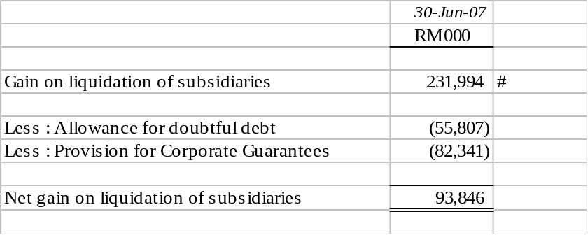
# Inclusive of finance costs attributable to LPC for first quarter ended 31 Mar 2007 amounting to RM 2.8 million.
19. MATERIAL EVENTS SUBSEQUENT TO BALANCE SHEET DATE
On 19 July 2007, the shareholders and creditors of Cardon have at their respective meetings approved the voluntary winding up of Cardon pursuant to S254(1)(b) CA 1965. As a result of the liquidation, Cardon ceased to be the subsidiary of the Company from the said date.
On 19 July 2007, the creditors of Cardon had also sanctioned the disposal of its 100% subsidiary Ark Construction Sdn Bhd (“ARKC”) to the Company, thus making ARKC, a direct subsidiary of the Company as of the said date.
The above events were conducted in line with the PCRE which was approved by the SC.
20. SEASONAL AND CYCLICAL FACTORS
There are no significant variations to the level of profit due to seasonal or cyclical effects of operations.
21. EXPLANATORY NOTE ON PROFIT FORECAST/GUARANTEE
No profit forecast / guarantee have been given by the company.
22. PROSPECTS
In tandem with the expected improvement in the economy, the Directors believe that the Group’s performance will progressively improve. The Group will continue with its ongoing efforts to improve operational efficiency to achieve better results.
23. DIVIDENDS
No interim or final dividend has been declared or recommended.

